**DAILY ONLINE ACTIVITIES SUMMARY**

|  |  |  |  |  |  |  |
| --- | --- | --- | --- | --- | --- | --- |
| **Date:** | **22/06/2020** | | | **Name:** | **Apoorva K N** | |
| **Sem & Sec** | **6th & A sec** | | | **USN:** | **4AL17CS012** | |
| **Pre-Placement Training Summary** | | | | | | |
| **Pre placement training** | **9:00 am to 11:00 am - Programming in C++**  **11:00 am to 1:00pm - Programming in C++** | | | | | |
| **Faculty** | | **MS. Shilpa**  **Ms.Ankitha Shetty** | **Duration** | | | **4 hr** |
| **Assessments** | | | | | | |
| **Problem Statement:**   1. Swapping of two numbers. 2. C program to print number of set of bits. 3. C++ program to overload &gt; operator. | | | | | | |
| **Status: Completed** | | | | | | |
| **Uploaded the report in GitHub** | | | **Yes** | | | |
| **If yes Repository name** | | | <https://github.com/Apoorva-K-N/pre-placement-training> | | | |
| **Uploaded the report in slack** | | | **Yes** | | | |

**Training snapshots:**

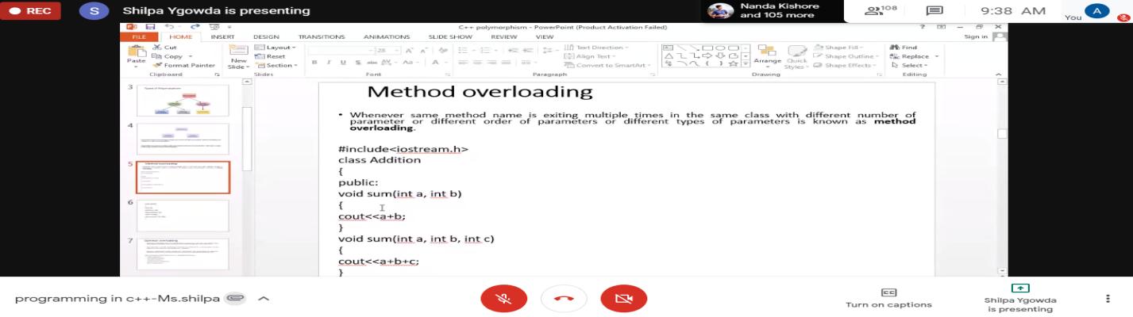

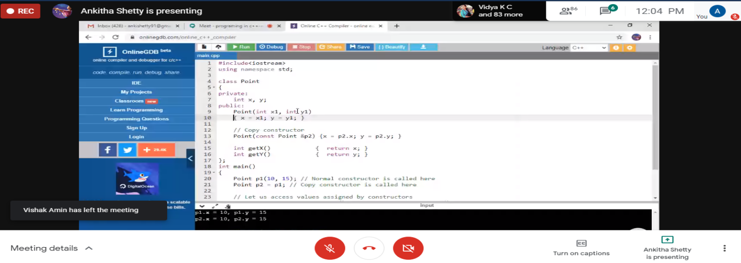

**Assessments:**

**Uploaded in GitHub in the above-mentioned repository.**

